**Impressionist Landscape Painting Workshop**

**Thursday 13th April 10.00 - 4.00**

* **Barchill Farm, Welford, Northamptonshire, LE17 6JL**

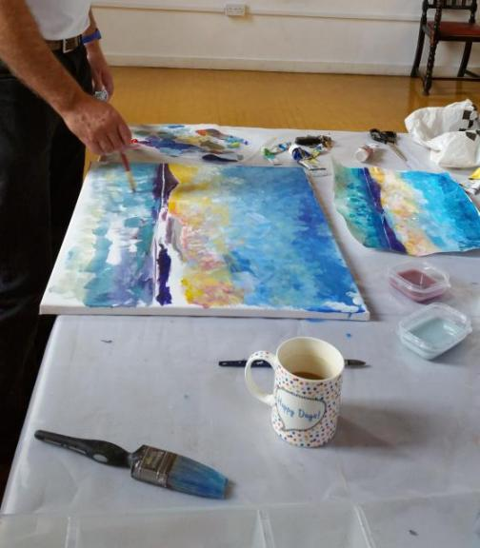

Ever wondered how the Impressionist artists such as Monet developed their technique? This workshop provides art historical knowledge, information on colour theory and Impressionist painting techniques and puts it all to practical use.

Deb Johnson is an experienced Artist, Lecturer with many years of teaching students of all levels.

Materials provided but feel free to bring your own.

This workshop is suitable for all levels from beginners to experienced.

Barchill Farm is set in glorious countryside on the border of Northamptonshire and Leceistershire and has beautiful gardens, the perfect subject matter for painting.

Sally, our host, will be providing tea and coffee and homemade lunch.

Cost £85.00

Email Deb Johnson - Tutor - for more details - [djartworks@hotmail.com](mailto:djartworks@hotmail.com)

Luxury accomodation available at Barchill Farm Retreat - see website for details

**Barchill-retreat.co.uk**